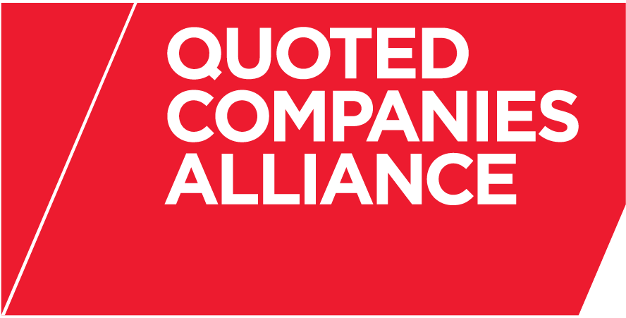

THE QUOTED COMPANIES ALLIANCE
CORPORATE GOVERNANCE EXPERT GROUP
PROPOSED MEETING DATES FOR 2013

All at 4.00pm unless otherwise advised (Revised time).

Tuesday 15 January 2013

Tuesday 19 March 2013

Tuesday 14 May 2013

Tuesday 16 July 2013

Tuesday 24 September 2013

Tuesday 12 November 2013

